Target 7465 3401
Stairway Labs

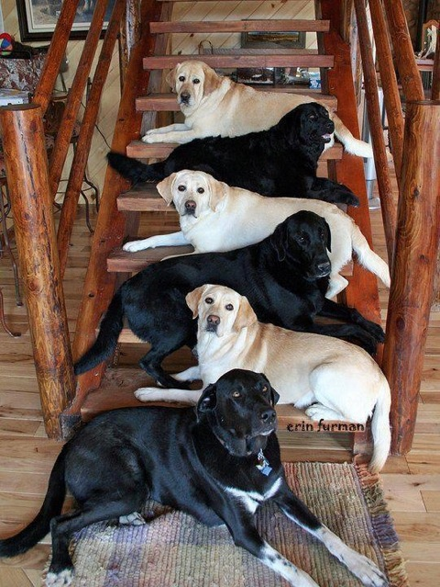

Fair Use For Teaching. Image retrieved 6/2013.
http://sphotos.xx.fbcdn.net/hphotos-snc7/428460_10150872382501235_1766232291_n.jpg

