Target 5831 2849
Peanut Harvest
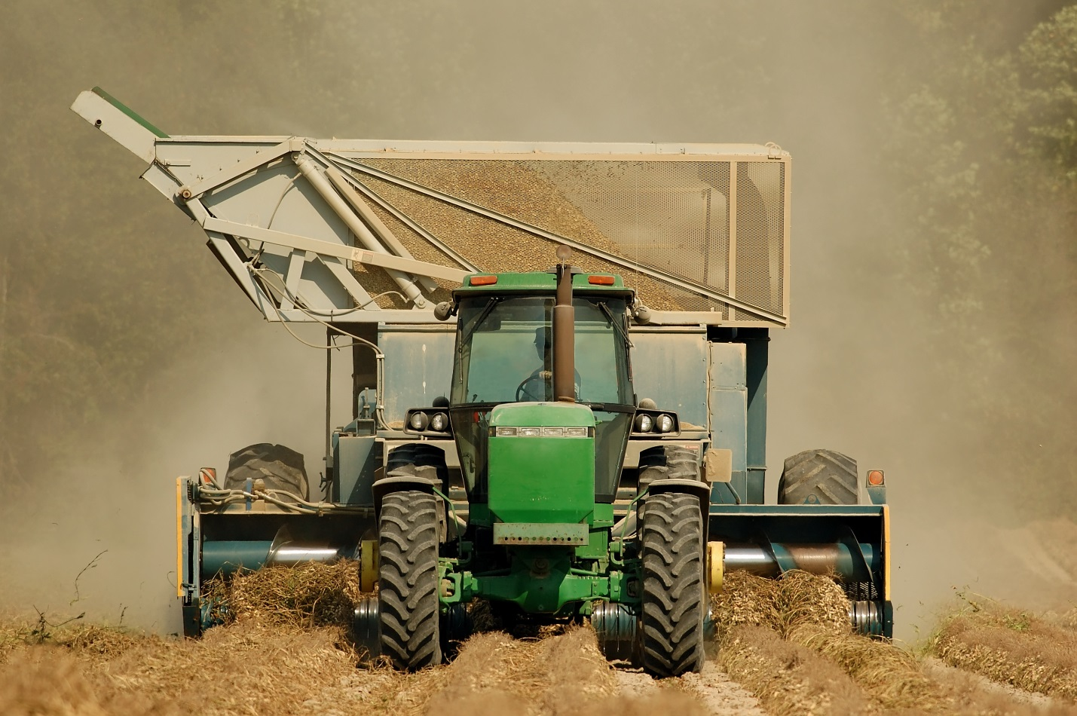
Tractor pulling a peanut combine.

Fair Use For Teaching. Image purchased from Dreamstime.
http://www.dreamstime.com/stock-photography-peanut-harvest-image1530932

