Target 5795 0296
Tulip Fields, Amsterdam

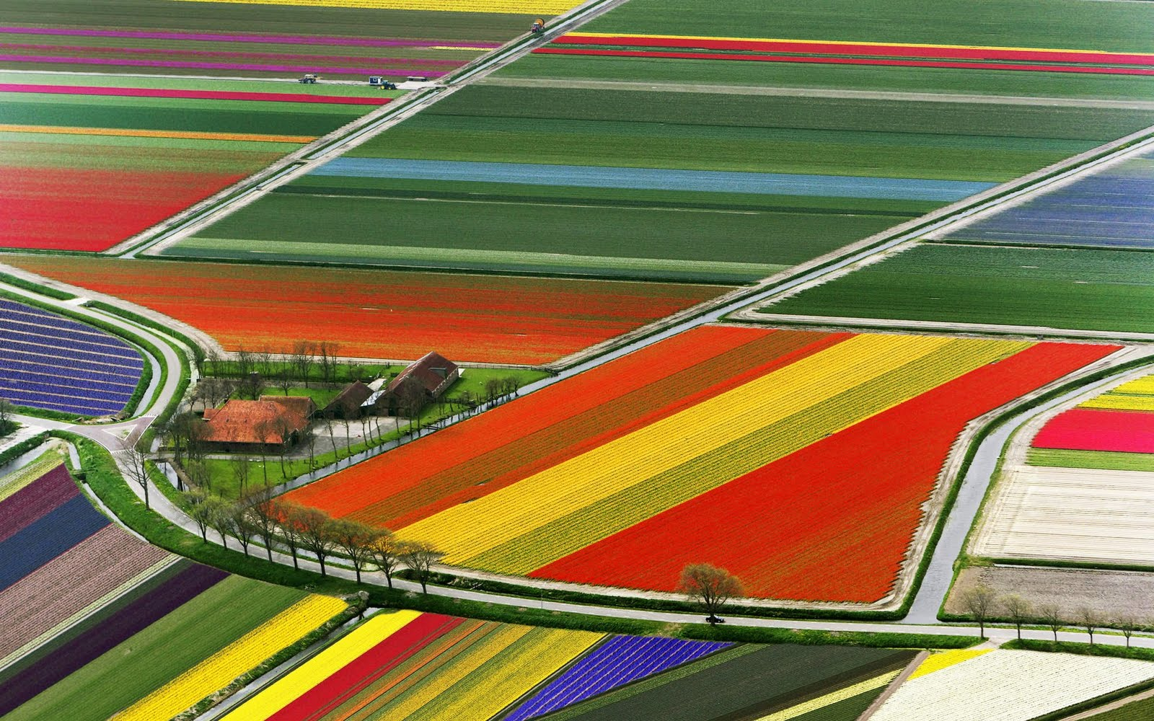

Fair Use For Teaching. Retrieved 6/25/13.
http://purple-emu.blogspot.com/2010/08/aerial-view-of-tulip-fields.html

