Target 5296 0463
Niagra Falls Aerial View
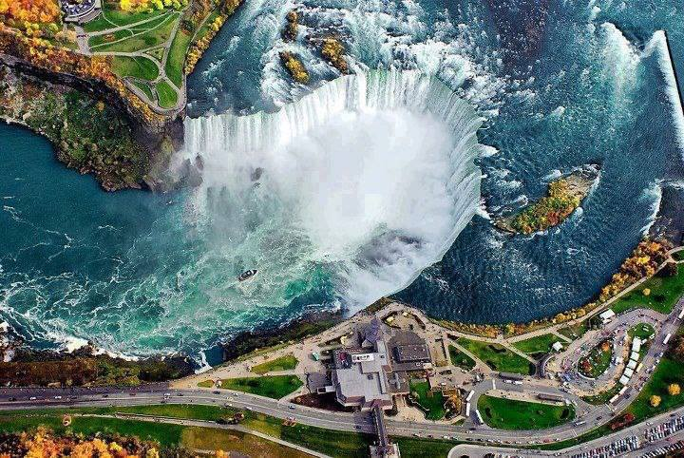

Fair Use For Teaching. Retrieved 6/25/13.
http://i1.mirror.co.uk/incoming/article1827864.ece/ALTERNATES/s2197/niagra-1827864.jpg

