Target 4673 5988
Ocean Ziplining, Jamaica

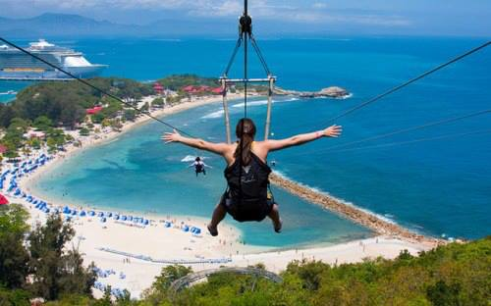

Fair Use For Teaching. Retrieved 6/25/13.
http://24.media.tumblr.com/tumblr_lpqv09uokd1qb62c4o1_500.jpg

