Target 4501 2497
The Longest Traffic Jam in the World, China

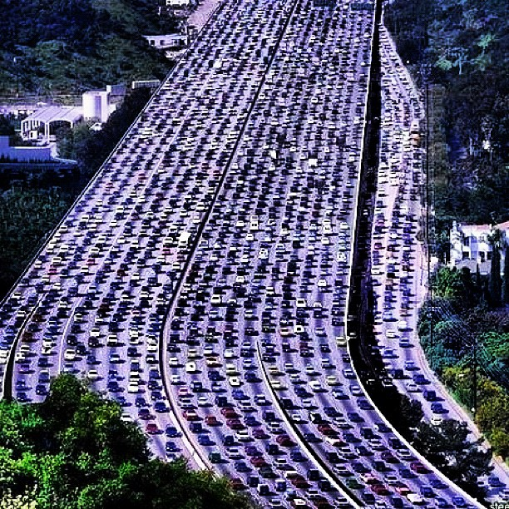

Fair Use For Teaching. Retrieved 6/25/13.
http://www.bubblews.com/news/282103-the-longest-traffic-jam-in-the-world

