Target 4212 8691
Blue Bridge For Ship Traffic, Belgium

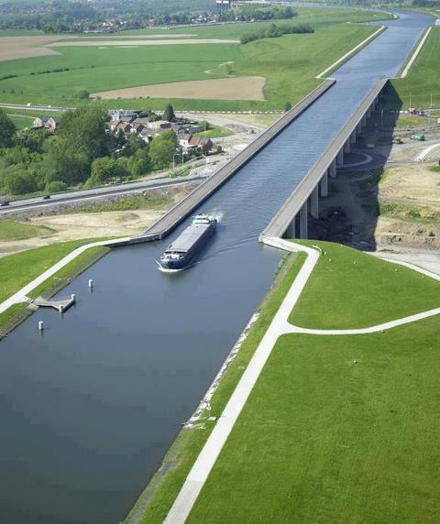

Fair Use For Teaching. Retrieved 6/25/13.
https://fbcdn-sphotos-a-a.akamaihd.net/hphotos-ak-ash3/p480x480/943395_242416689230879_640013545_n.jpg

