Target 3994 4920
Air Force Academy Chapel, Colorado

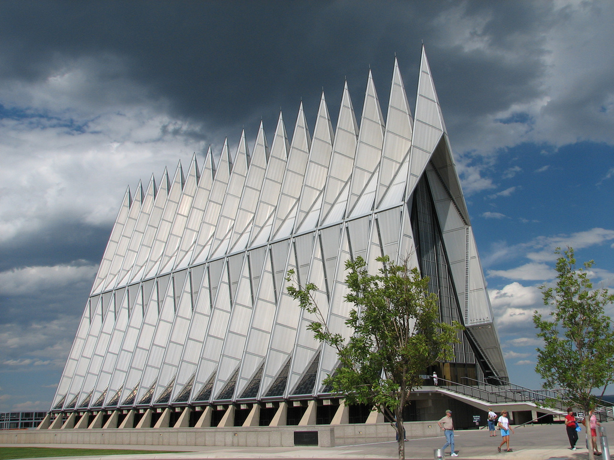

Fair Use For Teaching. Retreived 6/25/13.
http://aedesign.wordpress.com/2010/02/17/air-force-academy-chapel-colorado-united-states/

