Target 3073 1469
Olympic Torch, Beijing, China

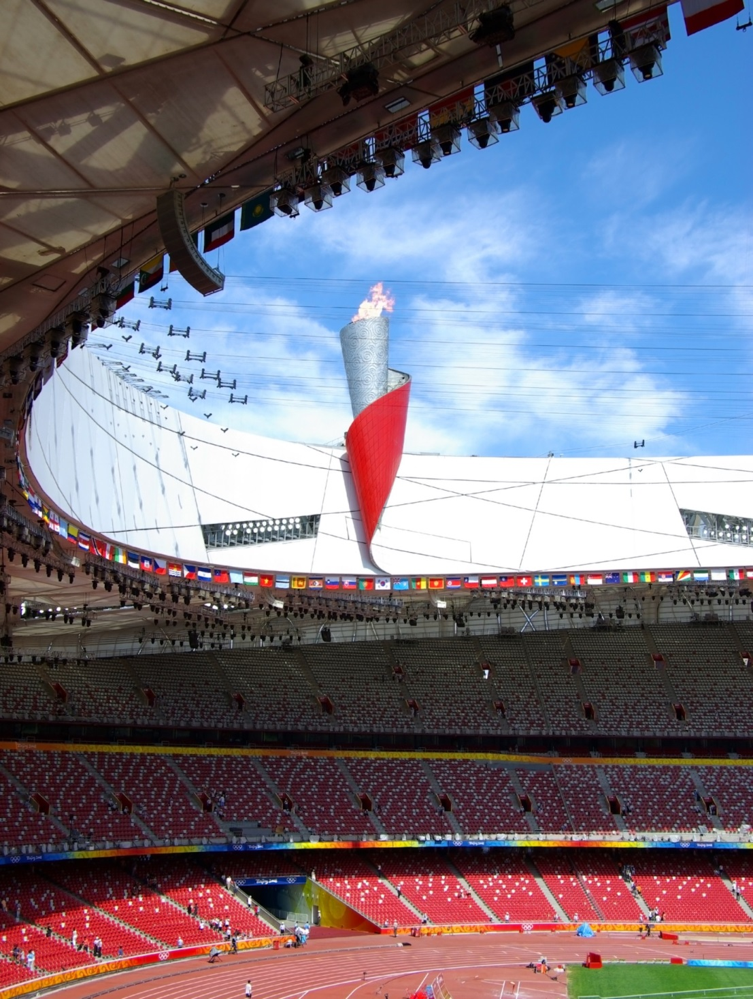

Fair Use For Teaching. Image purchased from Dreamstime.
http://www.dreamstime.com/royalty-free-stock-image-olympic-torch-image6076186

