Target 2710 6152
Dolphin Show
Mar del Plata Aquarium, Argentina

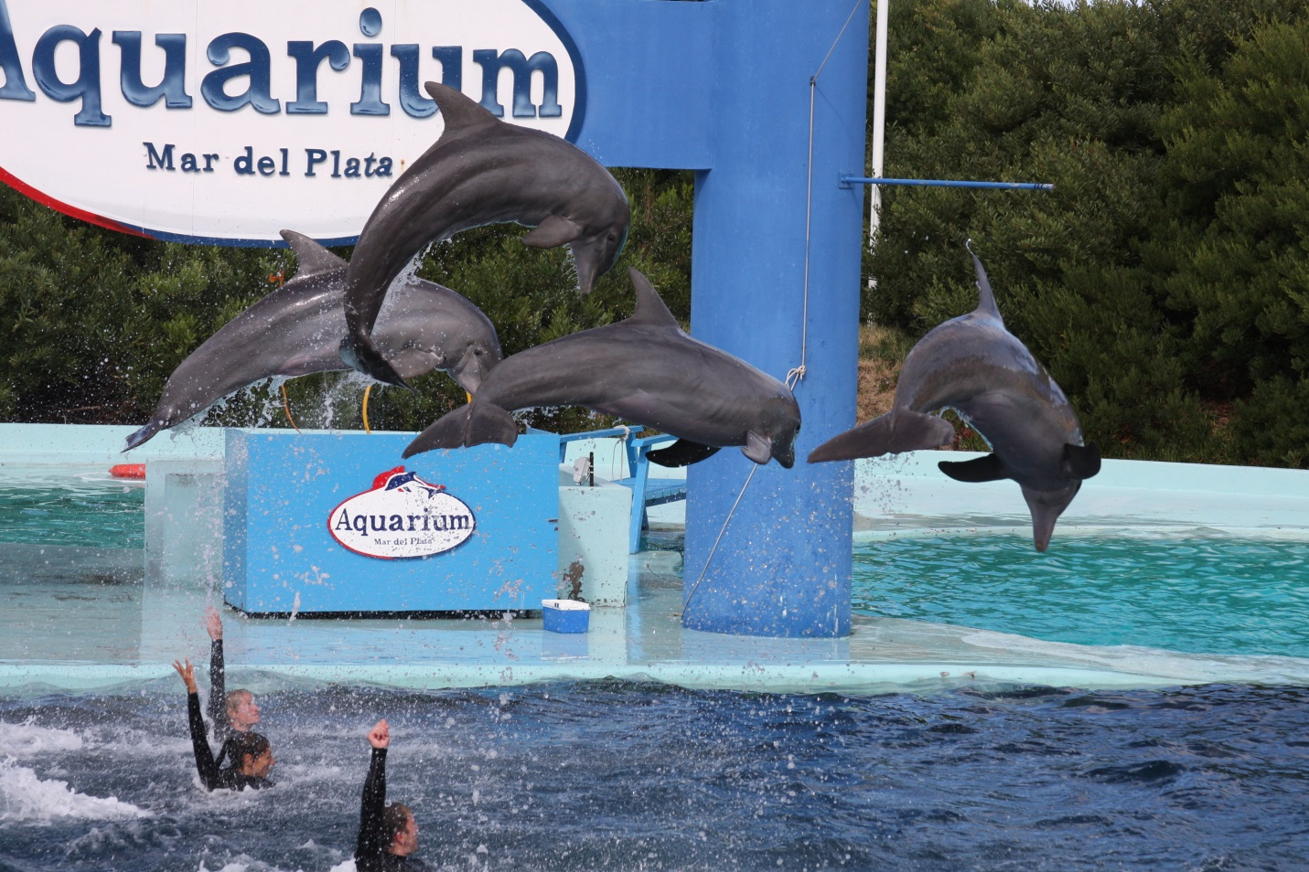

Fair Use For Teaching. Image origin unknown. Retrieved from the internet 6/2013.

